**Project Design Phase-II Technology Stack (Architecture & Stack)**

|  |  |
| --- | --- |
| Date | 16 November 2022 |
| Team ID | PNT2022TMID45099 |
| Project Name | Project - Customer Care Registry |
| Maximum Marks | 4 Marks |

**Technical Architecture:**

The Deliverable shall include the architectural diagram as below and the information as per the table1 & table 2

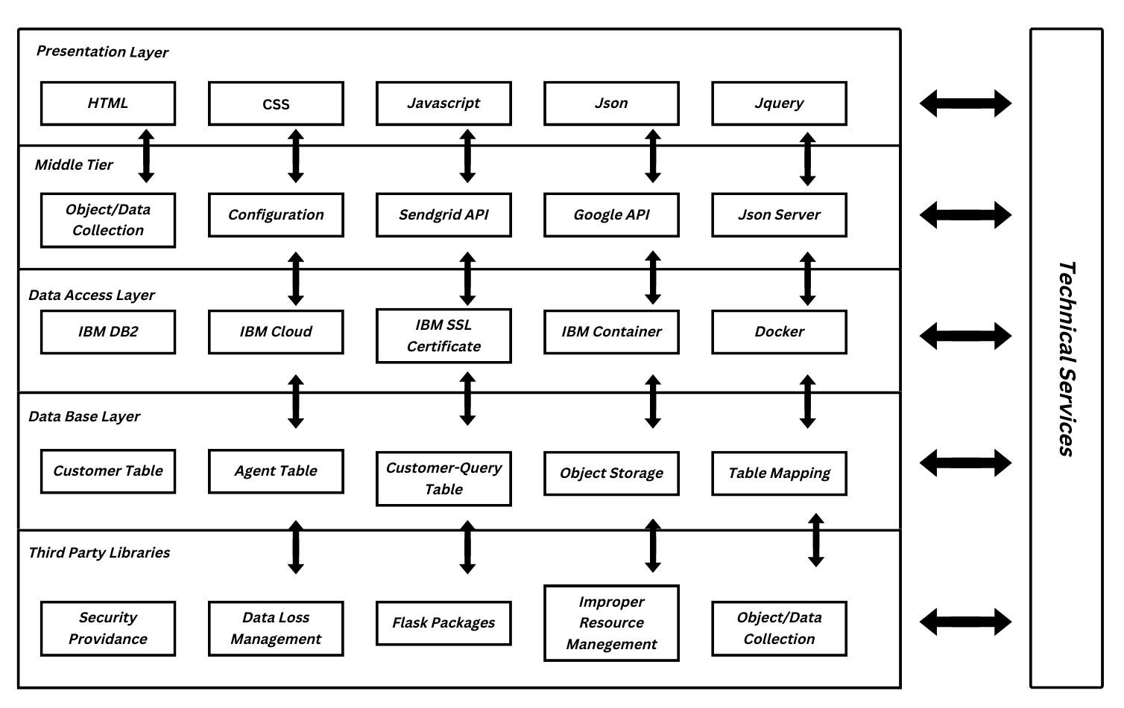

|  |  |  |  |
| --- | --- | --- | --- |
| **S.No** | **Characteristics** | **Description** | **Technology** |
| 1. | Open-Source Frameworks | Flask-Python Framework | Flask -Python |
| 2. | Security Implementations | Digital Certificate SSL Secuirty | IBM Cloud and IBM DB2 |
| 3. | Scalable Architecture | Sendgrid API and Json Server | IBM Object Storage |
| 4. | Availability | Large Number of Customer Utilize | IBM Kubernates |
| 5. | Performance | Fast Recovering Data From IBM DB2 and flexible request and response from Cloud | IBM Cloud |

**Table-1 : Components & Technologies:**

|  |  |  |  |
| --- | --- | --- | --- |
| **S.No** | **Component** | **Description** | **Technology** |
| 1. | User Interface | Similarly Like Chatbot,Web UI and etc… | HTML, CSS, JavaScript ,Json,Jquery |
| 2. | Application Logic-1 | It helps to perform the Entire Functions and Tasks in the Application. | Python |
| 3. | Application Logic-2 | Providing the Virtual Assistant for Customer Queries | IBM Watson Assistant |
| 4. | Database | Data from config. json is used to configure virtual machine. After that JSON syntax is valid. | JSON |
| 5. | Cloud Database | Database Service on Cloud | IBM DB2 |
| 6. | File Storage | File storage requirements | IBM Block Storage and Object Storage |
| 7. | Infrastructure (Server / Cloud) | Application Deployment on Local System / Cloud  Local Server Configuration:Local Server  Cloud Server Configuration : Online Server | Docker and Kubernetes |

**Table-2: Application Characteristics:**